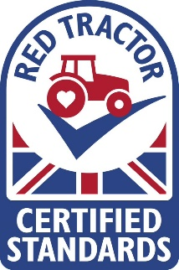
Name of Producer:________________________________________________________________
Address:________________________________________________________________________
_______________________________________________________________________________
Assurance Scheme Number:________________________________________________________
Name of person who transports livestock:_____________________________________________
Address:_______________________________________________________________________
_______________________________________________________________________________
_______________________________________________________________________________

I am a member of the following assurance scheme: Red Tractor QMS FAWL and can confirm that the vehicle used was inspected as part of the farm assurance inspection.
Assurance Scheme Number:________________________________________________________
I, confirm that I transport livestock for the above named Red Tractor member not for hire or reward.
I have understood and will comply with (EC) No 1/2005 on the protection of animals during transport and the Red Tractor Standards.
Signed: _________________________________________________________________________
Date:___________________________________________________________________________

Producer’s Signature: _______________________________________________________________
Date:_____________________________________________________________________________

DISCLAIMER
Any false information provided may invalidate both the assurance status of the vehicle owners stock and those transported, along with possible infringements of excise rules.

