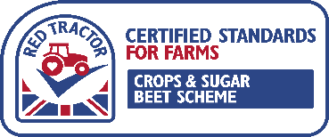
Hazards | Risk | Risk Rating |  |  | Preventative action taken
 |  | HIGH | MEDIUM | LOW
Lighting | Broken bulbs / glass in grain
Roof & wall sheets | Broken roof sheets / ingress of water
Air vents / openings | Contamination from birds & rodents
Floor (Stones/foreign objects) | Broken flooring / contamination of grain
Doors | Doors not closing properly / vermin & weather ingress
Machinery glass/plastic | Broken lens / glass / plastic in grain
Tractors / Trailers / Loaders (oil leaks) | Oil leaking from broken pipes / contamination of floor or crop
Grain dryer fuel | Diesel spillage / contamination
Birds | Salmonella or Newcastle disease
Rodents | Contamination of grain
Rodent Baits | Contamination of grain
Insect or mite activity | Contamination of grain
Mycotoxins | Contamination of grain

