Vermin Control - Site Survey
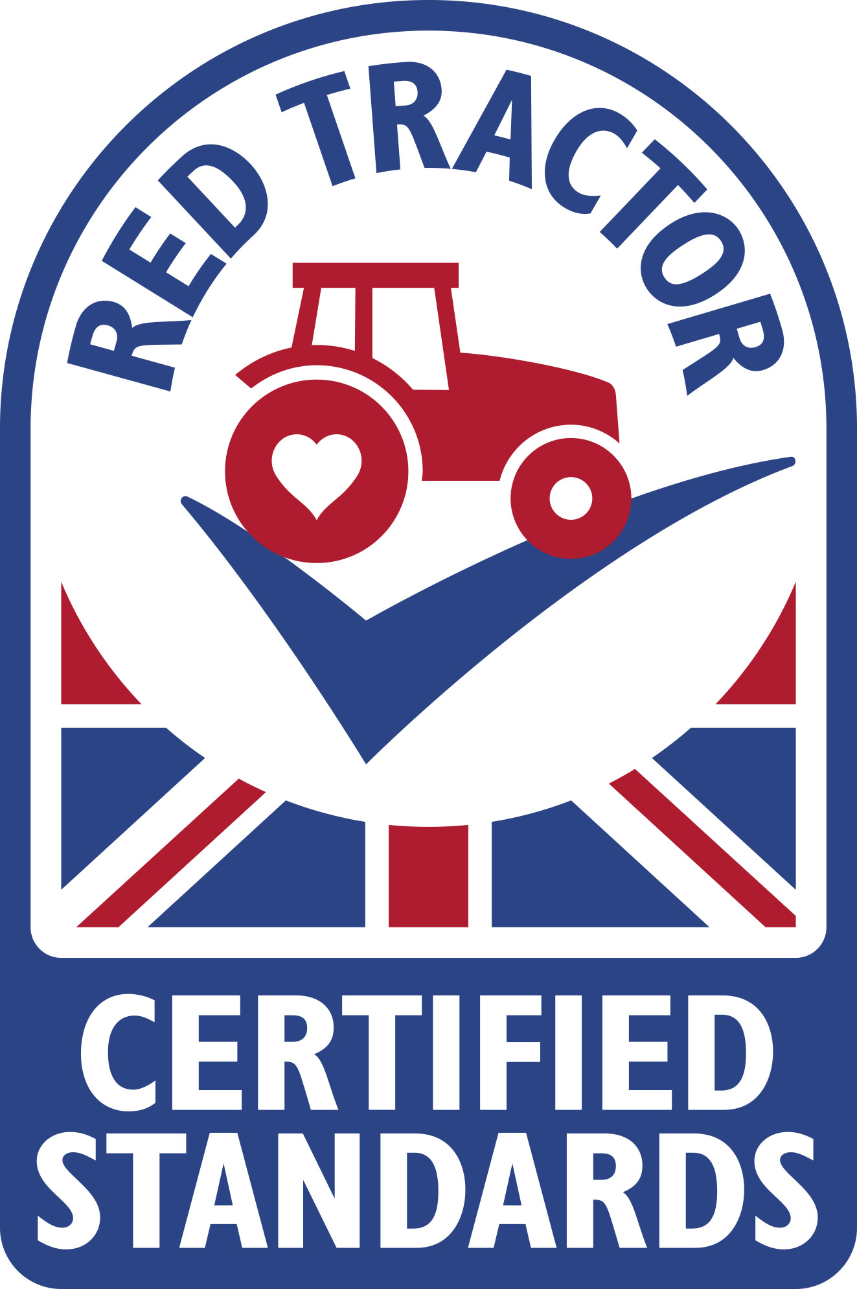
Date of inspection | Location(s) inspected  These can be marked on a map | Findings (inc. all potential opportunities e.g. spilt foods, gaps, habitats) | Actions Required (inc. what needs to be completed and by whom) | Date actions completed (initials to verify)

